02.70 MANAGER’S FINAL CHECKLIST

The following describes the functionality and features included in Probe Audit Premium+

Objective

The objective of this document is to provide the manager of the engagement team with a comprehensive checklist, organised by International Standard on Auditing, to confirm that all audit requirements have been met and all relevant matters have been appropriately addressed before finalising the engagement.

The following key concepts of the Probe Audit Premium+ Methodology are set in this document:
- Comprehensive quality review across all applicable ISAs at the manager level (ISA 220)
- Evaluation of the sufficiency and appropriateness of audit evidence obtained
- Quality control checkpoint between detailed senior work and the engagement partner’s final review

Document placement

Document 02.70 – Manager’s Final Checklist can be found in the Finalisation folder in the Caseware document manager.
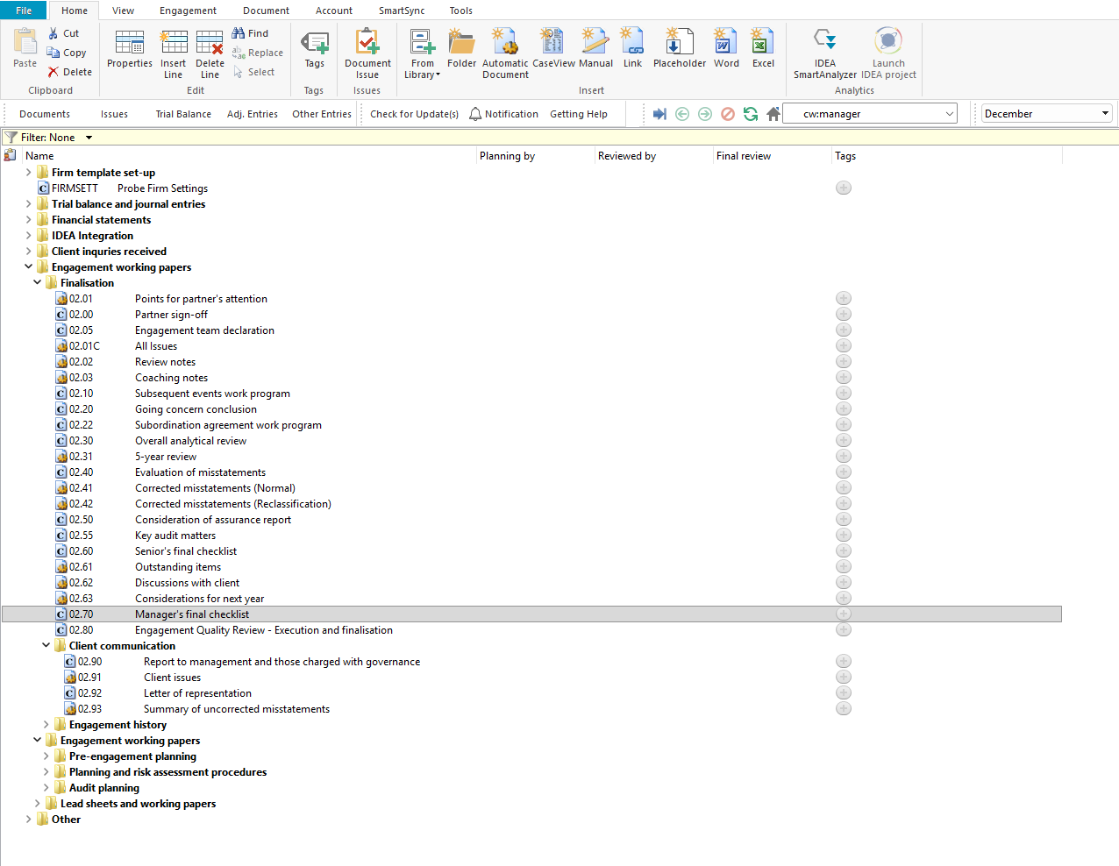

Document content

This document is designed to be a checklist type document that provides the manager of the engagement team with 42 considerations organised by International Standard on Auditing. The considerations are grouped under ISA sub-headings within the document to confirm that the requirements of each applicable ISA have been met.

The checklist covers ISA 200 (Overall Objectives), ISA 220 (Quality Management), ISA 230 (Audit Documentation), ISA 240 (Fraud), ISA 250 (Laws and Regulations), ISA 260 (Communication with Those Charged with Governance), ISA 265 (Communicating Control Deficiencies), ISA 450 (Evaluation of Misstatements), ISA 500 and 501 (Audit Evidence), ISA 505 (External Confirmations), ISA 520 (Analytical Procedures), ISA 530 (Audit Sampling), ISA 540 (Estimates), ISA 550 (Related Parties), ISA 560 (Subsequent Events), ISA 570 (Going Concern), ISA 580 (Written Representations), ISA 700 (Forming an Opinion), ISA 701 (Key Audit Matters), ISA 705 (Modifications to the Opinion), ISA 706 (Emphasis of Matter), ISA 710 (Comparative Information), and ISA 720 (Other Information).

This document is divided into different bookmarks in the document map to assist you in completing the manager’s final checklist:

Considerations
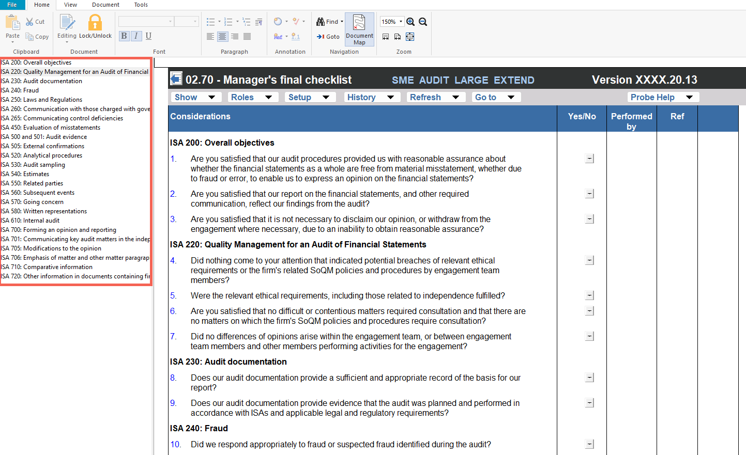

Layout
Column | Input Required | Outcome
Considerations
Considerations | No input is required in this column. The considerations are pre-populated and present 42 questions organised under ISA sub-headings. Each sub-heading identifies the relevant International Standard on Auditing, and the questions beneath it address the specific requirements of that standard. The ISA sub-headings covered are: ISA 200, ISA 220, ISA 230, ISA 240, ISA 250, ISA 260, ISA 265, ISA 450, ISA 500 and 501, ISA 505, ISA 520, ISA 530, ISA 540, ISA 550, ISA 560, ISA 570, ISA 580, ISA 700, ISA 701, ISA 705, ISA 706, ISA 710, and ISA 720. | No impact on the engagement file. Documents the considerations to be confirmed by the manager before finalising the engagement.
Yes/No | Select 'Yes' or 'No' to confirm whether each consideration has been addressed. All considerations should be answered 'Yes' before the engagement is finalised. | No impact on the engagement file. Documents the manager’s confirmation that each consideration has been addressed.
Performed by | Enter the name or initials of the engagement team member who confirmed each consideration and the date of confirmation. | No impact on the engagement file. Records who confirmed each consideration and when it was confirmed.
Ref | Enter a cross-reference to the relevant working paper or supporting documentation for each consideration. | No impact on the engagement file. Documents the cross-reference for the engagement file.

Document outcomes

The manager must confirm that all 42 considerations have been addressed by answering 'Yes' or 'No' to each question. All considerations should be answered 'Yes' before the engagement is finalised. Where a consideration is answered 'No', the engagement team must ensure that the matter is appropriately resolved before the engagement file is assembled and locked down. The checklist serves as evidence that the manager has reviewed the engagement for compliance with each applicable ISA, including overall objectives, quality management, documentation, fraud, laws and regulations, communication with those charged with governance, audit evidence, analytical procedures, estimates, related parties, subsequent events, going concern, written representations, the audit opinion, and reporting requirements.

Group Audits

When the engagement type was selected as 'Group Audit Single' or 'Group Audit Multiple', the manager’s final checklist applies to the group engagement. The engagement team must ensure that all considerations are addressed in the context of the group audit, including the involvement of component auditors and the adequacy of group audit documentation.

IN CONCLUSION

Features

The following features are available in the document:

Insert or delete a comment, see page F3

Guidance, see page F16

Freeze, see page F19

